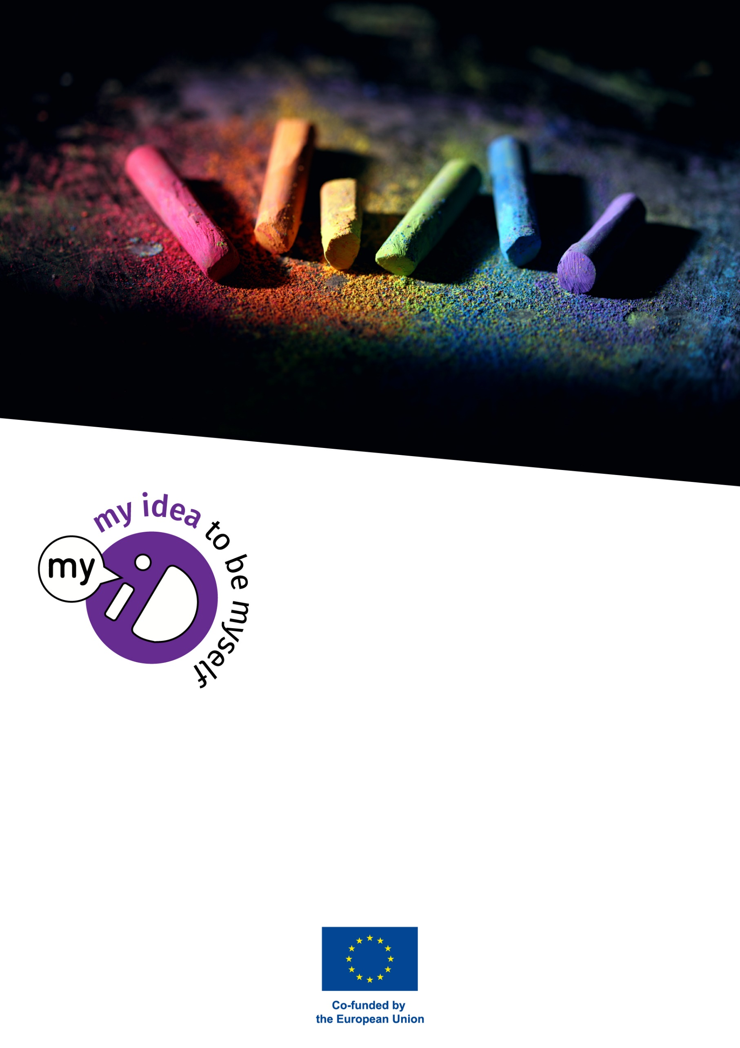
Teacher Guide to Implement and Develop My-ID Classroom Activities

Peter Dankmeijer, Max Rapa

Content
Summary of the Project 3
1. Introduction 4
1.1 How to choose the right activities 4
1.2 How to facilitate My-ID activities 6
2. How to write a My-ID classroom activity 8
a. How to prepare a My-ID activity 8
b. The activity itself 9
c. The left column 11
d. The summary 15
e. How to share your activity 16
3. Annexes 17
Colofon 17
Deliverable information 17
Project coordinator 18
Version history 18

Summary of the Project
The project intends to make schools more inclusive by addressing the LGBTIQ+ community problems in the educational system. Indeed, inclusive schools set the starting points from which students chart the course of the rest of their lives. Schools are the place where opinions form, values are established, and aspirations are set. In this framework schools are called to contribute to the promotion of equality and the prevention of discrimination.
As a result, many school educators may not be ready to address the problems of the LGBTIQ+ community in school because of lack of resources and knowledge. Thus, teachers may need basic knowledge about this topic. Also, teachers express the need to be trained, but also uncertainty on how raise the topic in class. Research indicates that about half of the teachers does not have adequate information to educate about gender issues during their time in classrooms. The large-scale FRA (2016) research on LGBTIQ+ and gender discrimination in EU shows that the students have a high need for more explicit attention for sexual orientation and gender identity.
Therefore, the main objective of this project is to support a comprehensive approach and specific educative actions to address intersectional discrimination and inequality experienced on grounds of sexual orientation, gender identity, gender expression and sex characteristics in the school. This can result to be challenging as these attitudes can be extremely difficult to change by the school, but the school is the right place to prevent any negative effects: there is a need to deal with homophobic negative effects on the students and their families.
Thus, the My-ID projects is very crucial, especially as it runs during a key time for the European education system. Indeed, it is on during the EU LGBTIQ+ Equality Strategy 2020-2025 adopted in 2020, that marks a new phase of integration of LGBTIQ+ equality in all policy areas and aims to bring together the Member States in a common endeavour to address LGBTIQ+ discrimination more effectively by 2025. Therefore, this project offers a good framework for future actions that needs to be filled in with concrete initiatives and My-ID can be one of these.

Introduction
This publication is a guide to support teachers during the implementation of the My-ID activities that can be found in the teachers’ manual. This Project developed a new technology to teach about sexual and gender diversity in high schools. The key element of this strategy is to not focus on cognitive learning, but on social and emotional learning. You can teach students the term “LGBTIQ+”, tell them about the rainbow flag, or install gender-neutral toilets in school, but none of these things will change their mind when they have aversive feelings towards (LGBTIQ+) diversity. Moreover, research shows that negative attitudes towards LGBTIQ+ are rarely a stand-alone phenomenon. Homophobia and transphobia are usually present in the same students that are also to some extent sexist, racist and xenophobic. Such attitudes are not genetic or a result of individual psychological development but are rooted in social environments and cultural and political systems. The classroom activities we offer here are attempts to deal with such issues in class, by incorporating the emotional, social, cultural, and political context of sexual and gender diversity but also the broader insecurity and intolerance that students may feel.

How to choose the right activities
We developed this publication with the general perspective that implementing ad hoc or single activities on sexual and gender diversity will not really make a great change in the attitudes of students or in the culture of your school.
Our advice is to develop a spiral curriculum. More information on how to develop a spiral curriculum can be found in the Curriculum Consultancy Manual, which was developed by the SENSE project.

In short, this could be done by jointly filling in a matrix like this:
Year | Subject 1  (e.g. social studies) | Subject 2  (e.g. biology) | Subject 3  (e.g. language) | Subject 4  (e.g. sports)
Entry level
Year 1
Year 2
Year 3
Year 4
Exit level

A school can choose in which subjects they want to locate attention for sexual and gender diversity. This may be social studies and biology, because in those subjects the exam standards often already require attention for health, sexuality, and diversity. But to promote the ‘normality’ and to break through heteronormativity, it can be very useful to also integrate attention for sexual and gender diversity, or diversity in general in other subjects. This makes it more ‘matter-of-fact’ and part of the school culture.
When creating such a spiral curriculum, it would be good to assess the knowledge and attitudes of students when they enter school (entry level) and to agree on what type of attitudes and behaviour the school wants the students to have at the end of their high school career (exit level). This makes it easier to plan a series of activities that coaches the students from their starting level to the level that the school aspires to.
This matrix and the rationale behind it make it very clear why single and ad hoc classroom activities on their own will not have much effect. Changing student attitudes towards more tolerance and interest for diversity is a long-term goal, that needs to be built up gradually and over the years. It would be also counterproductive if one teacher would promote one type of attitude, while other teachers promote other attitudes or neglect diversity. The development of emotional intelligence and personal growth of students should be part of each subject and the task of all teachers and all other staff members of the school. Only by this way, you can offer students a safe and coherent school climate.
Many schools will already have activities and textbooks, with or without the context of a spiral curriculum. Therefore, it is useful to explore what the current perspectives and activities of the school are towards gender, relationships, sexuality, diversity, and discrimination. It could be explored whether the current activities are adequate enough to reach the desired school goals in these areas. The spiral curriculum matrix can help to enhance the coherence of the current activities and to add activities to strengthen the student competences and the school culture.

How to facilitate My-ID activities
“My-ID” classroom activities differ from many traditional programs and lessons on LGBTIQ+ topics by having more attention for the needs, fears, and emotions of students. This may be a bit challenging for some teachers. Many teachers have been trained to be experts and to transfer knowledge, or to train concrete manual skills. In this context, giving attention to emotions may be perceived to be “therapeutic” and even as “unprofessional”. We don’t agree with that perspective. In the Netherlands, one politician suggested that schools should return to more traditional teaching like calculus, for example “learning how much the cost is of too many immigrants”. This anecdote clearly shows how seemingly technical approaches can be loaded with underlying emotional, attitudinal, and even political issues. Technical or academic approaches, whether they are applied through calculus, language, history, geography, or sports are always inspired by specific worldviews and underlying needs and goals. The My-ID approach does not negate this, but wants to help clarify this and to add some views and activities that promote tolerance and diversity. In this effort, the My-ID approach is in line with worldwide human rights values and the European strategies on equality and LGBTIQ+ equality.
The more horizontal approach of the My-ID method (as opposed to top-down transfer of knowledge and skills) has considerable consequences for the way the activities are facilitated by teachers. In most activities we choose for discussion methods like “dialogue”. A proper dialogue is a conversation in which the participants (students and teacher) participate on an equal level and exchange experiences and views without arguing which view is the best, or to “win” with arguments or intimidation. My-ID activities are about personal growth and about exploring your position in society. In My-ID activities, we see teachers as coaches of this personal growth. Their role is to create a safe environment in which students can have a dialogue in which it is possible to share emotions and attitudes without being judged by other students or teachers. The teacher’s role is to stimulate openness and curiosity and to help students to understand themselves and others. We believe that by doing this, the created safe and open space will automatically (but gradually) lead to more empathy with others, more tolerance, more interest in diversity, and less discrimination. In our view, teachers should not urge or tell students what to think or do, but to create a positive and challenging environment in which students themselves come to the conclusion that marginalization and discrimination is dysfunctional.
Heteronormativity
In many countries, sexual and gender diversity is still a sensitive topic because the social and cultural environment of students tells them that same-sex relations or gender change is weird, unnatural, or immoral. In a more abstract sense, we could say that most traditional views on sexuality and gender see such diversity as a threat to traditional family life, which some people suppose will destroy society and the nation state. This attitude is called heteronormativity. The My-ID approach is to question whether diversity will really destroy society, or whether diversity can better be viewed as a variation and enrichment. Teachers using the My-ID approach should learn to feel secure in their opinion that sexual and gender diversity is a normal and integral part of society. They should be aware that negative remarks about sexual and gender diversity are based on fear and insecurity and that the task of the teacher is to help students overcome this irrational fear.
(More about this can be found in the teacher training program and the teacher training background reader the My-ID project developed.)

How to write a My-ID classroom activity
In this chapter, we present the My-ID template for describing classroom activities and explain how you can use it to develop your own activity.

How to prepare a My-ID activity
We advise to prepare your activity by first brainstorming about your ideas and jot down some notes. Most teachers will first think about the concrete implementation of the activity and how to make it attractive for students.
But just as important, or even more important, is to be clear about the objectives of the activity and how you can see if your activity is a success (beyond the students having fun doing it). In your brainstorm notes, you can explore how the concrete activity is reaching your objectives. Often, this will either lead to changing your objectives or to change the activity to better match your intended objectives.
When you have a clear idea about the right direction (objective-oriented) of the activity, you can edit your brainstorm notes to make more clear which steps the teacher will take to implement the activity.
After your brainstorm, it is time to develop the brainstormed notes into a text that is not only useful for your own reference but can also be understood and used by other teachers. This textual development takes some thinking about how the activity should be presented. You will need to re-read your text with the eyes of someone else who does not know what you know or intended.
We advise to write the summary of the activity as the last part, because it is easier to make a summery when you have the final overview of the entire activity.

The activity itself
The My-ID template suggests dividing the activity itself into three sections:
- Previous requirements and/or preparation
- Implementation
- Transfer to practice

PREVIOUS REQUIREMENTS AND PREPARATION
Many lessons need some previous requirements. For example, one of the activities in this compendium asks students to do a small research on the attitudes and knowledge of students about sexual and gender diversity. This is a math assignment which requires previous knowledge about basic statistics. Other activities may require an environment in which you can have a dialogue in which our students feel comfortable enough to express their feelings and opinions without fear of being judged. The previous requirement for such a lesson would be that the teacher has made sure that the class environment is safe enough to do this lesson. Just having school rules about proper behaviour does not establish this type of safety. It is good to be explicit about such requirements in the beginning of the description of the activity.
Usually, the teacher needs to do some preparation. Some activities asked the students to walk around, which means the teacher had to prepare their classroom to make this possible. Other activities make use of handouts, that need to be copied.

IMPLEMENTATION
The section about implementation describes how the activity is going to be carried out. This is done by giving the teacher directions for the different steps to make. It is best to formulate these directions directly, like: “ask the students to form subgroups of three” rather than: “the teacher divides the students in groups of three”.
Most lessons will consist of 4 steps, or variations on four phases.

Four phases in lessons
1. a trigger: a video, joke, anecdote, or question to get the interest and curiosity of the students
2. an introduction: an explanation by the which teacher about what the lesson will be about and why. This is also the phase where the teacher can ask if students want to engage in this activity; in democratic schools, students have the right to refuse if they don’t like the topic or the method.
3. the activities itself: which can consist of several methods like brainstorm, video viewing, a game, a role-play, or dialogue.
4. the activity usually closes with a debriefing: a closing reflection in which the students and the teacher summarize the learning impact of the activity and - if necessary - make a link to daily life. It works better if the students do this themselves; if the teacher dictates what the conclusion is, it can come across as authoritarian, patronizing or inauthentic.
To make the description of the activity clearer for teachers, each step is numbered and starts with the number of minutes the step should take and one or two words to indicate the method used in the step (for example: “Step 3, 5’; brainstorm”).
When you think that inexperienced teachers need really detailed information to make the step, you could insert a frame with a cursive literal text that they could say, for example as an introduction, an explanation or to summarize the activity in the debriefing. You could also insert a frame with additional information when you think that teachers may not have the essential information they need to facilitate the activity. For example, we added such informational frames in some activities for the subject of history, because we expect that many history teachers are not aware of the history of sexuality and gender and need some key information, next to the reference to sources we are providing.

TRANSFER TO PRACTICE
One of the most important aspects of education is that what has been learned theoretically has to be transferred to practice. The “transfer to practice” is realized and strengthened when what is learned is actually used in follow-up lessons and daily life. This extremely important aspect is often forgotten in compartmentalized education (in which all classes and subjects are considered separate units that are unrelated to each other). Therefore, we have put the section “transfer to practice” as a reminder in the template.
Concrete transfer to practice can simply be repeating or practicing something explicitly. But it can also be done by making off-hand comments and reminders in lessons or in other situations, like during lunch breaks or in the hallways.
Transfer to practice can also be to translate “learned issues” to systematic change in school procedures and policies. For example, when a lesson promotes asking for pronouns, and not assuming that people will be male or female based on first impressions, the transfer to practice can be an initiative to update questions about gender in school administration forms.

The left column
The My-ID activities have a left column which offers short information that help teachers to select the activity.

OBJECTIVES
The objectives describe what the teacher wants to reach with students. Objectives should be described in terms of the students, “The students know, feel, can, or do something”.

KASB objectives
Objectives can be described in terms of knowledge (“the students know”), attitudes (“the students are aware off, are curious, feel, form an opinion” etc.), skills (“students can research, can treat someone respectfully”) or/and behaviour (“students research, act respectfully, ask for pronouns”.
Make sure the stated objectives are really objectives that you can reach with this specific activity. For example, “The students learn how to ask for pronouns and to make assumptions about someone’s gender.” An objective like “A safe school climate is established” is too broad and too ambitious; it cannot be reached with one activity. It is also not formulated in terms of what the students know, feel, can or do due to this specific activity, so you won’t be able to check after the activity if you actually reached your objective.

INDICATIONS OF IMPACT
The indicators of impact describe what the teacher can observe in the end of the lesson(s) when the objectives are reached. We added this section, because we know that many teachers lose track of the original objectives during a lesson. Many teachers feel that a lesson is successful when the students were highly engaged and enthusiastic. However, when you give all the students a high-sugar drink and a piece of pie, they will also be positive about the lesson, while it remains questionable whether you reached your goal (unless your objective was to teach appreciation of pie ).
The indicators of impact can be described in terms of concrete behaviour you hope the students will exhibit at the end of the lesson. This could be that they repeat or interpret specific information (knowledge), that they are aware of, or appreciate specific feelings or opinions (attitudes), that they demonstrate how you can do some things (skills) or that they do something spontaneously in the lesson or express an intention to do something specific after the lesson (behaviour).
The indicators of impact should not be a repetition of the objectives, but describe the proof the teacher can see when the objectives are reached.
Example Math
Objective: Students learn about the meaning of LGBTIQ+ labels and symbols and have better understanding why people feel a need for such categorisation.
Indicators: The students present the correct meanings of LGBTIQ+ labels and symbols and agree there is a need for detailed categorizations and labelling.
Example Greek
Objective: Students learn about Sappho and become aware of the relative invisibility of lesbians (even compared to gays and transgenders).
Indicators: Students show they are curious about Sappho’s work. They show they are aware that LGBT poems and songs and especially about love between women are rather rare and offer their opinion why.

DURATION
The left column gives a short indication of the duration of the activity, like “30 minutes” or “3 lessons of each 1 hour”.

LEVEL
The left column gives indications for the level. Because school levels are different in each country, we suggest to list the age range for which the activity is best used, and to divide the level of development of the students in “low”, “intermediate” or “high”.
With “low level” we refer to high school students who have difficulty learning, need a lot of explanation and support by the teacher, and who need a lot of time to understand and to carry out an assignment.
With “intermediate level”, we mean a class that can understand short instructions and can carry out an assignment with little support by the teacher. Such students are commonly able to work rather autonomously and in small groups but with some supervision. They should be able to make short but not too complicated presentations to other students.
With “high level”, we mean a class with students that are almost functioning on an academic level. Such students need very little instruction and only need marginal guidance to do an assignment. They can do assignments completely autonomously and they can work in larger groups, in which they can organize a task division among themselves. They can do adequate online research and they grasp abstract concepts. They can have unsupervised discussions among themselves without getting into arguments.
In comprehensive schools, students of all levels may be together in one class. For such classes, it is advisable to use intermediate level activities if you want to involve the whole class. If you want to tailor the activities to different levels of students, you could make subgroups of lower and higher performing students and give them specific assignments with a good relevance for the activity. Make sure that by making subgroups for different levels of students, such students are not set apart or blamed for their level. You can do this by making their assignment indispensable for the activity. For example, you can ask higher level students to do some more in-depth research and report on it, or to coach other students. You can ask lower-level students to focus on exploring the feelings and opinions that they and other people have around the topic at hand, rewarding their emotional input but avoiding overly complicated tasks.

MATERIALS
The section on materials gives a short description of the materials that are needed to carry out the activity. Materials that are common in every classroom, like a blackboard, whiteboard or electronic board, pens and papers do not need to be mentioned. But if there are handouts that need to be copied or specific other materials that are not readily available in the classroom, they should be mentioned here.
In the My-ID activities in this compendium, we usually provided handouts as an annex to the activity. In some cases, we have added a link to a video, or a PowerPoint presentation that can be downloaded.

VERSION
We think it is important to give credit to the authors of classroom activities, to give the date that they were developed and possibly the inspiration for the activity. The activities in this compendium are copyright free, but we appreciate it when you mention in case you republish or edit an activity.
It is useful to mention the year of development; some activities that were developed in 1980 may still look interesting but may need editing to be better usable in current times.
It is also useful to mention an inspirational source if you have one. It may help users of the activity to dive deeper into the issues at hand and it offers proper credit to other authors.

The summary
Although the summary is presented as the first text the reader sees after reading the title, we advise to write it as the final part of the template. After the entire activity is finished, it is easier to write a clear summary.
The summary is written in terms of what students concretely do and learn. Don’t be too vague, abstract and don’t focus on objectives (these are already in the left column). Examples:
A history activity
Students study and discuss the poems of the Greek poetess Sappho, discover the historical, lyrical, and cultural dimension of them and consider how the sexual diversity was perceived by Sappho.

A physical education activity
Students are asked to approach each other and set boundaries for other students approaching. In short debriefing moments, the students reflect on how it is to set boundaries and if gender and sexual orientation play a role.

How to share your activity
After taking the effort to write an interesting classroom activity, we can understand that you would like to share it with other teachers. Many countries have online platforms, where teachers share ideas for lessons. This is one way of sharing your activities.
You can also send us your activity to the My-ID partnership (https://myid-project.eu/, “contact us”) or to GALE (The Global Alliance for LGBT Education), who will probably love to publish your activity on the My-ID website, share it on the My-ID Facebook page of publish it in the GALE activity database (mail to info@gale.info) .

Annexes

Colofon

Quote as
Dankmeijer, Peter; Rapa, Max (2023). Teacher Manual to Implement and Develop My-ID Classroom Activities. Madrid/Amsterdam: DEFOIN/GALE

Deliverable information
Grant Agreement No.
Project acronym | My-ID
Project title | My-ID – My Identity, My Idea to be Myself
Project timeframe and duration | 2021-1-IT02-KA220-SCH-000034423  1 November 2021 – 30 November 2023
WP | 1 Classroom activities
Task | 1.4
Deliverable | 1.4 Teacher manual for classroom activities
Status | Final publication + slight adaptations by GALE
Version number | 4
Deliverable responsible | DEFOIN
Dissemination level | Public
Expected due date | 1 May 2023
Date of this version | 23 June 2023

Project coordinator
Name
Organization | Fondazione Villa Montesca

Version history
Version | Date | Author | Description
1 | 12-4-2023 | Peter Dankmeijer | Draft introduction
2 | 3-5-2023 | Max Rapa | Second draft
3 | 15-5-2023 | Max Rapa | Publication
4 | 23-6-2023 | Peter Dankmeijer | Updated publication

